

**Tribhuvan University**

**Faculty of Humanity and Social Sciences**

**Bachelor’s in computer application**

**Daily Activities & Personal Finance Tracker**

**Submitted To**

Department of Computer Application

Padmashree International College

Tinkune, Kathmandu

*In partial fulfillment of the requirements for the Bachelors in Computer Application*

**Submitted By**

**Jenish Limbu** **Kiran Jethara**

Registration No: Registration No:

6-2-622-28-2021 6-2-622-29-2021

Under the supervision of

**Basanta Chapagain**



**Tribhuvan University** **Faculty of Humanities and Social Science**   
**Padmashree International College**

# **SUPERVISOR’S RECOMMENDATION**

I hereby recommend that this project prepared under my supervision by “**Jenish Limbu”** and **“Kiran Jethara”** entitled “**Daily Activities & Personal Finance Tracker”** in partial fulfillment of the requirements for the degree of Bachelor of Computer Application recommended for the final evaluation.

……………….

Mr. Basanta Chapagain

Project Supervisor

Department of Computer Application

Padmashree International College



**Tribhuvan University**

**Faculty of Humanities and Social Sciences**

**Padmashree International College**

# **LETTER OF APPROVAL**

This is to certify that this project prepared by “**Jenish Limbu”** and **“Kiran Jethara”** entitled “**Daily Activities & Personal Finance Tracker”** in partial fulfillment of the requirements for the degree of bachelor’s in computer application has been evaluated. In our opinion it is satisfactory in the scope and quality as a project for the required degree.

|  |  |
| --- | --- |
| **………………………………..**  Mr. Basanta Chapagin  Supervisor  Department of Computer Application  PadmaShree International College | **………………………………….**  Mr. Ramesh Kumar Pudasaini  Program Coordinator  Department of Computer Application  PadmaShree International College |
| **………………………..**  **Internal Examiner** | **…………………………**  **External Examiner** |

# **ABSTRACT**

This report describes the creation of the "Daily Activities and Personal Finance Tracker," a web-based application designed to help users organize their daily tasks and manage their finances more effectively. The main aim was to develop an easy-to-use platform that provides tools for budgeting, tracking expenses, monitoring income, and managing daily activities. Utilizing Agile development practices, the project was built in iterations, incorporating ongoing user feedback and adapting to evolving requirements. The system includes features for task scheduling, financial tracking, data visualization, and basic security measures. The development involved technologies such as HTML, CSS, JavaScript, and PHP, which ensured a smooth and efficient user experience. Challenges related to database design and system integration were addressed through detailed research and problem-solving. Comprehensive testing, including unit and System testing, was performed to guarantee the system's stability and reliability. The outcome is a user-centric solution that enhances personal productivity and financial management. Future improvements could involve adding advanced data analysis tools, optimizing the mobile experience, strengthening security protocols, and incorporating multi-language support.

**Keywords**: ***Daily Activities Tracker, Income Tracker, Expense Tracker, Budgeting Expenses, Web Based Application.***

# **ACKNOWLEDGEMENT**

We would like to express our heartfelt gratitude to several individuals whose support and guidance were instrumental in the successful completion of our project. First and foremost, we extend our deepest appreciation to **Mr. Basanta Chapagain, Mr. Ramesh Kr. Pudasaini, Hemant Gautam** and **Mr. Yubaraj** **Rai** for their invaluable knowledge, ideas, and unwavering support throughout the project.

Additionally, we are immensely grateful to all of our classmates who contributed their insights, feedback, and encouragement, helping us refine our work and stay motivated. Their collaborative spirit and willingness to share knowledge played a crucial role in the project's development.

We also wish to acknowledge the support of our professors and mentors who provided expert guidance and resources, ensuring that we stayed on the right track. Their expertise and constructive criticism were vital in overcoming challenges and enhancing the quality of our work.

**TABLE OF CONTENTS**

SUPERVISOR’S RECOMMENDATION i

LETTER OF APPROVAL ii

ABSTRACT iii

ACKNOWLEDGEMENT iv

LIST OF ABBREVIATIONS vii

LIST OF FIGURES viii

LIST OF TABLES ix

Chapter 1: INTRODUCTION 1

1.1 Introduction 1

1.2 Problem Statement 1

1.3 Objectives 2

1.4 Scopes and Limitation 2

1.5 Report Organization 3

CHAPTER 2: BACKGROUND STUDY AND LITERATURE REVIEW 4

2.1 Background Study 4

2.2 Literature Review 4

CHAPTER 3: SYSTEM ANALYSIS AND DESIGN 5

3.1 System Analysis 5

3.1.1 Requirement Analysis 6

3.1.2 Feasibility Analysis 8

3.1.3. Data Modelling (ER-Diagram) 10

3.1.4 Process Modelling(DFD) 11

3.2. System Design 13

3.2.1. Architectural Design 13

3.2.3. Interface Design(UI Interface / Interface Structure Diagrams) 13

CHAPTER 4: IMPLEMENTATION AND TESTING 19

4.1 Implementation 19

4.1.1 Tools used 19

4.2 Testing 23

4.2.1 Test Case for Unit Testing 24

4.2.2 Test Case for System Testing 27

CHAPTER 5: CONCLUSION AND FUTURE RECOMMENDATION 28

5.1 Lesson Learnt/outcomes 28

5.2 Conclusion 28

5.3 Future Recommendations 29

REFERENCES 30

APPENDICES

# **LIST OF ABBREVIATIONS**

**CSS** Cascading Style Sheet

**DFD** Data Flow Diagram

**ER** Entity Diagram

**HTML** HyperText Markup Language

**Js** JavaScript

**UI** User Interface

**UX** User Experience

# **LIST OF FIGURES**

Figure 3.1 Agile Methodology 5

Figure 3.2 Use Case Diagram of Daily Activities and Personal Finance Tracker 7

Figure 3.3 Gantt Chart of Daily Activities And Personal Finance Tracker 9

Figure 3.4ER Diagram of Expenses 10

Figure 3.5 ER Diagram of Income 10

Figure 3.6 Level 0 DFD 11

Figure 3.7 Level 1 DFD 12

Figure 3.8 Web Architectural Design. 13

Figure 3.9 Homepage 14

Figure 3.10 Registration 15

Figure 3.11 Login 16

Figure 3.12 User Dashboard 17

Figure 3.13 Admin Dashboard 17

Figure 3.14 User Profile 18

# **LIST OF TABLES**

Table 4.1Test Case for User Registration 24

Table 4.2 Test Case For Login 25

Table 4.3 Test Case for Adding Tasks 26

Table 4.4 Test Case for System Testing 27

# **Chapter 1: INTRODUCTION**

## **Introduction**

The “Daily Activities & Personal Finance Tracker” is a system which helps to view and analyze the daily tasks, income and expenses of an individual .It is a system developed to track the tasks, income and expenses. It serves as a valuable tool in this regard, helping individuals to plan, monitor, and optimize their daily tasks while also keeping a close eye on their financial health. In short, this system is designed to record and analyze time and money of a user.

## **1.2 Problem Statement**

On a daily basis, many people fail to complete all their tasks or forget to prioritize them based on their importance. This often happens because they do not track their tasks according to their due dates or importance. Consequently, they miss deadlines and fail to complete tasks in a timely manner.

In financial matters, many people overspend without considering their income or without being aware of how much money they are spending on a daily basis. They do not manage their spending through proper budgeting, which leads to unnecessary expenses and increased overall costs. By failing to track their expenditures and plan their finances, they often find themselves facing unexpected financial difficulties.

## **1.3 Objectives**

The objectives of “Daily Activities & Personal Finance Tracker” are:

* To provide users with a comprehensive view and tracking system for their daily activities and personal finance-related data.
* To enable users to analyze and make decisions about their tasks and income/expenses.
* To assist users in maintaining disciplined habits.

## **1.4 Scopes and Limitation**

**1.4.1 Scope of the project**

The "Daily Activities and Personal Finance Tracker" is a comprehensive web application designed to help users manage their daily tasks and track their income and expenses efficiently. Users can organize their tasks by priority and due dates, enabling better time management and productivity. Additionally, the application provides tools for budgeting and expense tracking, helping users gain insights into their spending habits and financial status .

**1.4.2 Limitations**

The limitations of "Daily Activities and Personal Finance Tracker" are:

* Internet access is required as it is a web-based application.

## **1.5 Report Organization**

**1.5.1 Introduction**

This chapter introduces the system, outlining its objectives and limitations, and explains the reasons behind its development.

**1.5.2 Background Study and Literature Review**

This chapter presents an overview of the current issues, highlights the significance of developing the system, and defines key concepts related to it, while also providing a critical review and summary of existing research in the field.

**1.5.3 System Analysis and Design**

Different requirements such as functional and non-functional requirements, feasibility analysis, ER diagrams, DFDs, system architecture, database schema, and interface design are included in this chapter.

**1.5.4 Implementation and Testing**

This chapter focuses on the tools utilized in system development, detailing the implementation process and presenting the results of the tests conducted.

**1.5.5 Conclusion and Future Recommendation**

This chapter provides a brief summary of the lessons learned, the outcomes, and the conclusions of the entire project. It explains what has been accomplished and suggests potential areas for further improvement.

# **CHAPTER 2: BACKGROUND STUDY AND LITERATURE REVIEW**

## **2.1 Background Study**

Numerous System Catering to "daily activities and personal finance tracker” populate the market, with personal experiences and analyses applied to platform like Todoist, Clocklify, Ynab etc. Currently, users contend with a divide, necessitating separate applications for managing daily activities and monitoring personal finances.

## **2.2 Literature Review**

Daily activities and personal finance tracker systems have evolved from simple digital tools to sophisticated mobile and web-based applications, offering a range of benefits for users. These systems enhance productivity by identifying and optimizing time management, facilitate better financial management through budgeting and goal setting, and empower data-driven decision-making with detailed analytics. Despite their advantages, challenges such as privacy concerns, user engagement, complexity, and integration with other platforms need to be addressed. Future trends in AI, voice and gesture controls, blockchain technology, and wearable device integration promise to further enhance the functionality and accessibility of these systems, making them indispensable tools for personal management in the digital age.

# **CHAPTER 3: SYSTEM ANALYSIS AND DESIGN**

## **3.1 System Analysis**

Agile's emphasis on flexibility, user collaboration, and iterative development makes it an ideal choice for developing our system. This approach ensures that the system remains adaptable and responsive to user feedback, ultimately delivering a high-quality product. Since our system requirements weren’t clear and may include additional features in the future, Agile methodology is the best-suited approach for our project.

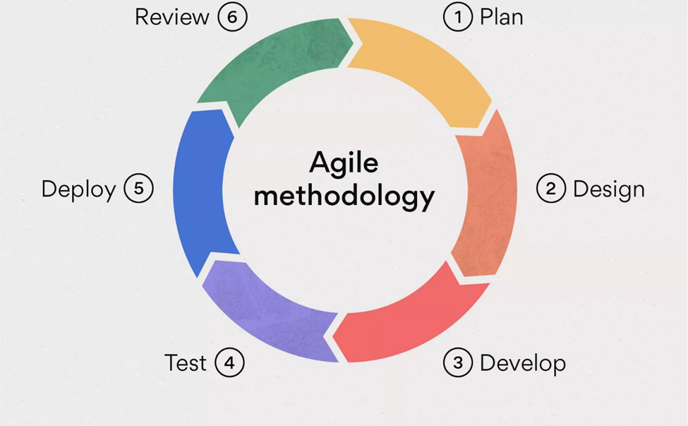

**Figure 3.1 Agile Methodology**

### **3.1.1 Requirement Analysis**

#### **i. Functional Requirement**

The functional requirements are listed below:

1. **Users**

* The system is authenticating and authorizing the users while logging in.
* The system is tracking the tasks added by the users.
* Users is being able to add the income and expenses category.
* Users may allocate the budget for his/her monthly expenses.
* The system is tracking the income and expenses of users.

1. **Admin**

* The system is authenticating, authorizing and redirecting to the admin dashboard.
* Admin can deactivate users.
* Admin can change the website UI/(motives) contents.
* Admin is getting messages sent by the website visitors.

**Use Case Diagram of Daily Activities and Personal Finance Tracker**

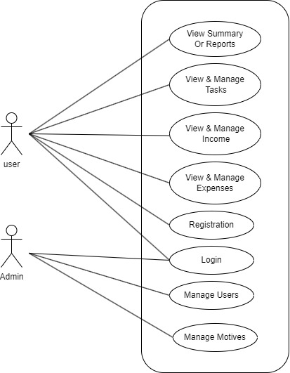

**Figure 3.2 Use Case Diagram of Daily Activities and Personal Finance Tracker**

#### **ii. Non-Functional_Requirement**

1. **Availability**

The system should be available at any time, providing users with 24/7 access every day of the year. Users should access the system at any time, requiring devices and an internet connection. Additionally, the system should be compatible with multiple browsers ensuring seamless and flexible access across various platforms. This high level of system availability should guarantees that users can rely on the service whenever they need it.

1. **Accuracy**

The system should be 100% accurate with the inputted data and the tracking results.

1. **Reliability**

The system must be reliable, as it plays a vital role in tracking and providing data about users' tasks, incomes, and expenses.

1. **Security**

The system must protect all the users data and authorize, authenticate the users while logging in.

### **3.1.2 Feasibility Analysis**

#### **i. Technical Feasibility**

The Daily Activities and Personal Finance Tracker system is technically feasible due to its reliance on modern, robust technologies. The front-end will use HTML5, CSS3, and JavaScript, while the back-end will be powered by php with database MySQL.

#### **ii. Operational Feasibility**

The Daily Activities and Personal Finance Tracker ensures smooth operation by offering a good UI, seamlessly fitting into daily routines and valuing user feedback for continuous improvement. The system optimizes user time and delivers trustworthy data. It can be operated by normal user with no professional experience.

#### **iii. Economic Feasibility**

The Daily Activities and Personal Finance Tracker is economically feasible enough to run the system. The system is going to be created with free sources and the users won’t have to pay to use this system.

#### **iv. Schedule Feasibility**

The system is being developed with the below timing schedules.

**Figure 3.3 Gantt Chart of Daily Activities And Personal Finance Tracker**

### **3.1.3. Data Modelling (ER-Diagram)**

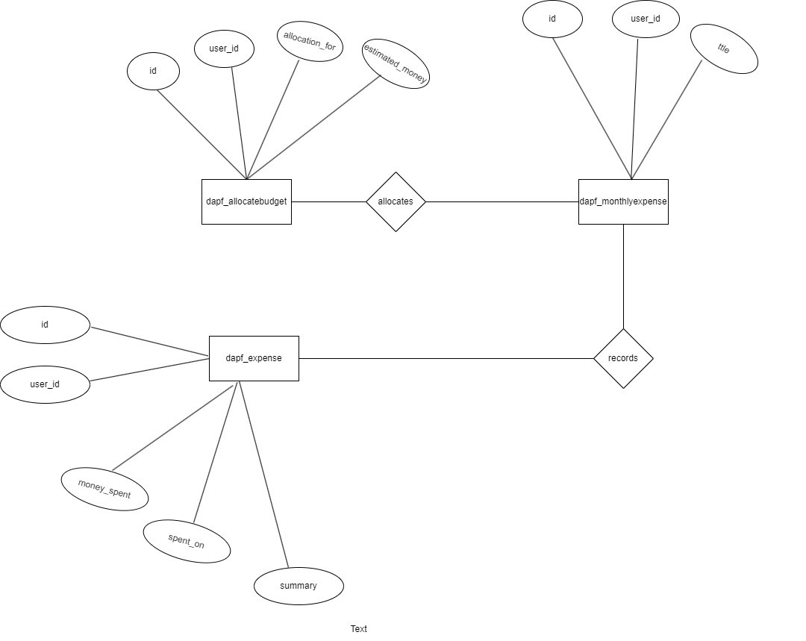

**Figure 3.4ER Diagram of Expenses**

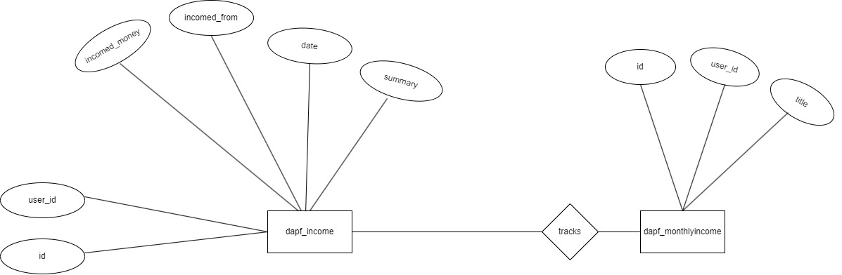

**Figure 3.5 ER Diagram of Income**

### **3.1.4 Process Modelling(DFD)**

**Level 0 DFD**

The Level 0 Data Flow Diagram (DFD) for the Daily Activities and Personal Finance Tracker illustrates the primary interactions between Users and the System. Users have the ability to monitor daily activities, handle their finances, and establish budgets. Core processes include logging daily activities, recording expenses, managing income, setting and adjusting budgets, and logging in/out. Data flows cover activity logging, expense recording, income management, budget allocation, and authentication credentials. This streamlined diagram showcases the key functionalities and communication pathways within the system, facilitating effective management of daily routines and financial matters.

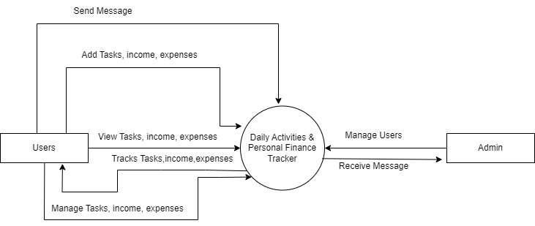

**Figure 3.6 Level 0 DFD**

**Level 1 DFD**

The Level 1 DFD provides a more detailed view of the Daily Activities and Personal Finance Tracker. It breaks down the processes into sub-processes and includes database/data storage components.

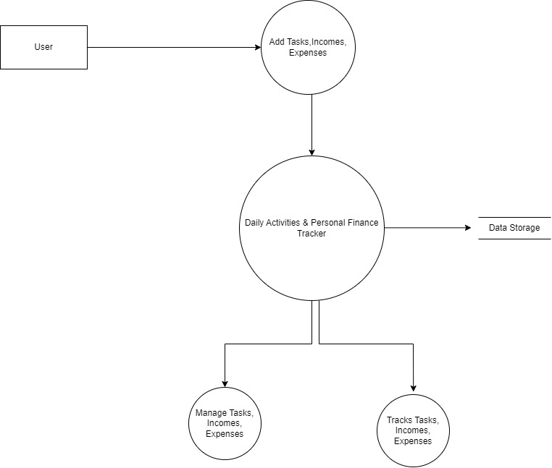

**Figure 3.7 Level 1 DFD**

## **3.2. System Design**

### **3.2.1. Architectural Design**

Three tier architecture is being implemented in this system. The Figure is given below:

**Figure 3.8 Web Architectural Design.**

### **3.2.3. Interface Design(UI Interface / Interface Structure Diagrams)**



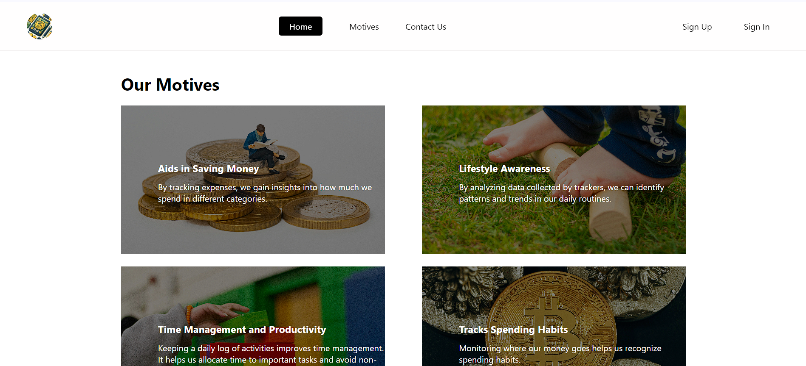

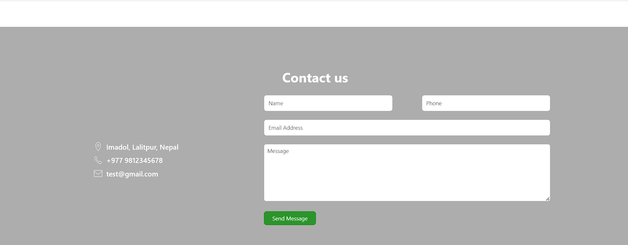

**Figure 3.9 Homepage**

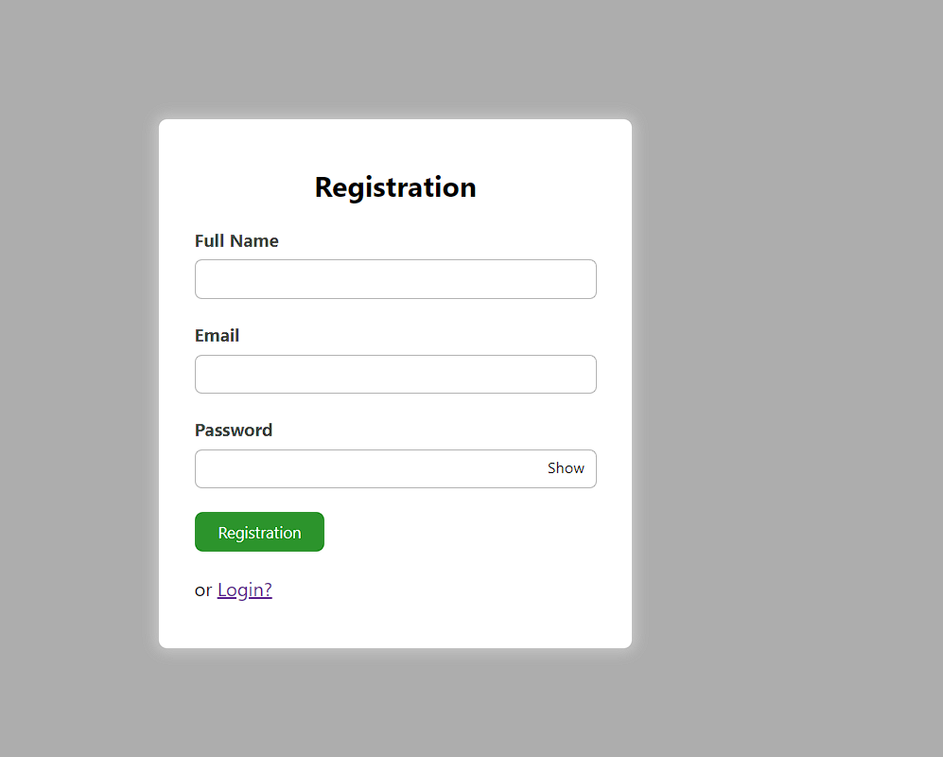

**Figure 3.10 Registration**

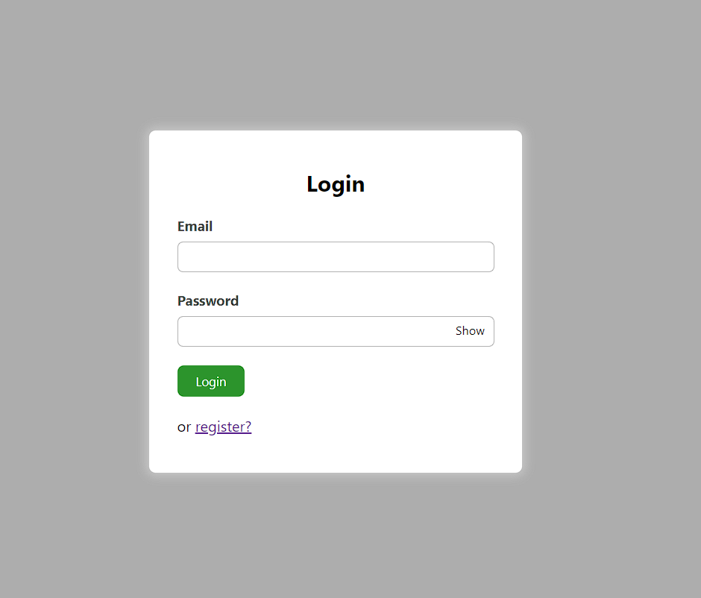

**Figure 3.11 Login**

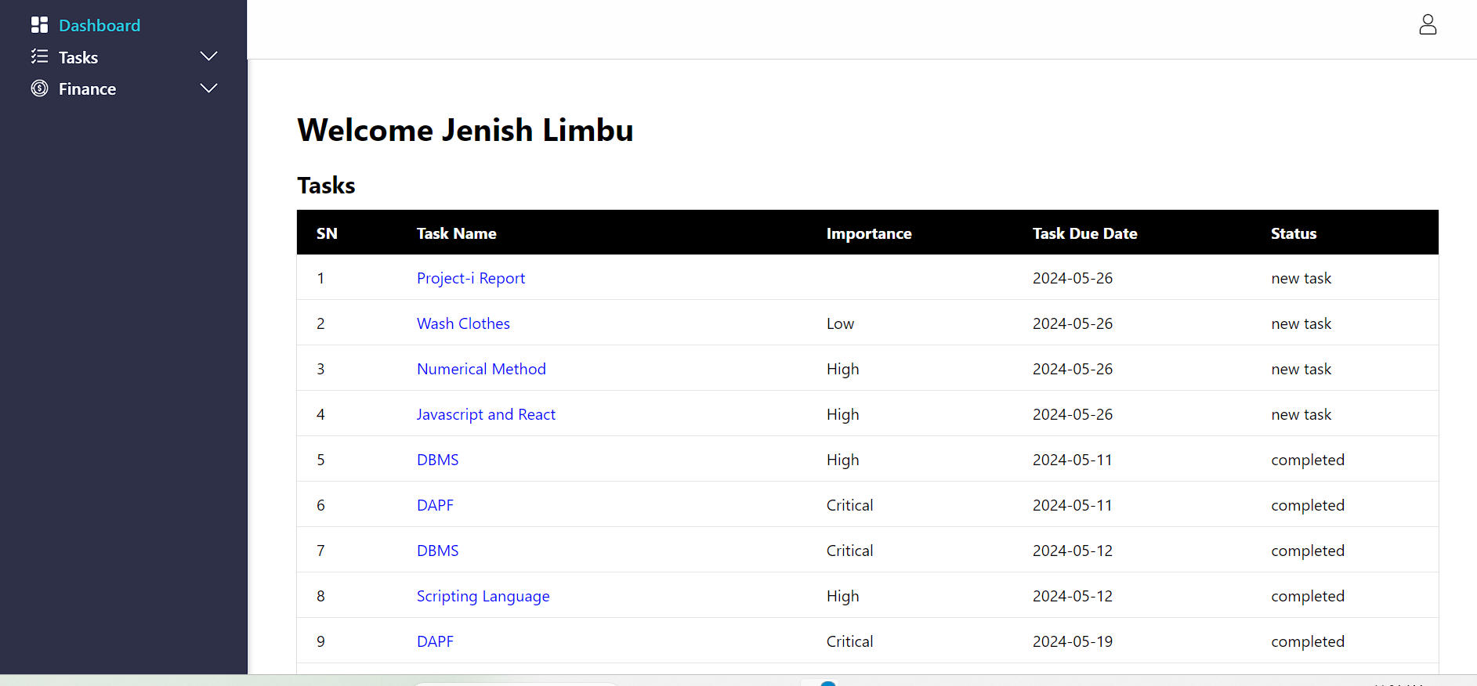

**Figure 3.12 User Dashboard**

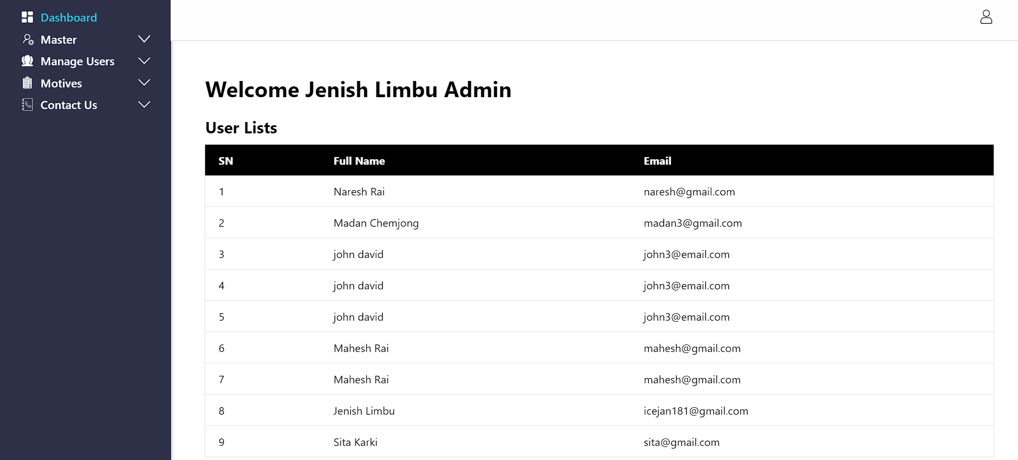

**Figure 3.13 Admin Dashboard**

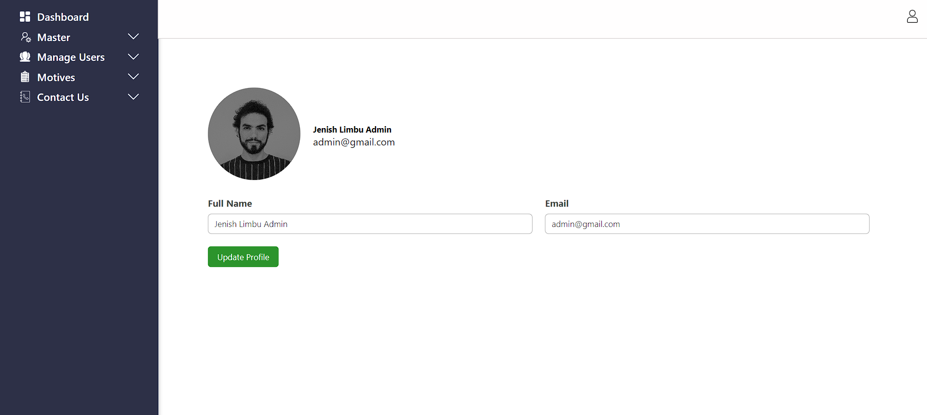

**Figure 3.14 User Profile**

# **CHAPTER 4: IMPLEMENTATION AND TESTING**

## **4.1 Implementation**

In this phase, the coding for different modules and functions of the Daily Activities and Personal Finance Tracker system is implemented. Each module and function is developed according to the specifications outlined in the system design phase, ensuring they meet the intended requirements. The system includes modules for tracking daily activities, managing personal finances, allocating budgets, recording monthly expenses and incomes, and maintaining daily tasks.

### **4.1.1 Tools used**

The different tools used in this project are:

**4.1.1.1 Front End Tools**

**HTML**

In our system, HTML (Hypertext Markup Language) was used to create all the elements and nodes. Various HTML tags, such as <a>, <head>, <body>, and <img>, were utilized throughout the project. By using a variety of HTML tags, we were able to create a well-structured and user-friendly interface for our Daily Activities and Personal Finance Tracker system

**CSS**

In our system, CSS (Cascading Style Sheets) was used to design the overall project. Its various design attributes provided significant help in creating an attractive UI.

**JavaScript**

JavaScript was used for different functionalities like toggling sidebar contents, hiding or showing the password in login and registration forms etc. JavaScript helped us to create an dynamic design.

**4.1.1.2 Backend Tools**

**PHP**

The overall data handling, including storing, updating, deleting, and fetching data, was done with the help of PHP. It was used to connect with the database management system, making our system's data dynamic for users.

**Apache Server**

XAMPP has been used in our project as a local development environment to facilitate the creation and testing of our system. It provides a local server environment consisting of Apache, MySQL, and PHP. By using XAMPP, we were able to host our project locally, allowing us to develop and test the application in a controlled environment.

**Database**

**MySQL**

MySQL is being used in our project as the primary database management system to handle all data-related operations. It is being used for manipulating the data in our project, such as storing, updating, fetching, and deleting. MySQL has allowed us to efficiently manage user information, track daily activities, record financial transactions, and handle other essential data for the system. This made our system dynamic and responsive to user interactions, providing a stable and scalable solution for our project's data management needs.

**4.1.1.3 Documentation Tools**

**MS PowerPoint**

We used PowerPoint for the presentation of our project. All the presentation presented by us were made possible with the help of MS PowerPoint.

**MS Word**

The report submitted by us were created in MS Word. Its various features and technologies helped us in creating our project report. We used MS Word for formatting the text, creating tables, inserting images, and adding references. The spell-check and grammar-check features ensured our reports were error-free.

**Draw.io**

Draw.io helped us in creating various diagrams, such as ER diagrams, flowcharts, and Data Flow Diagrams (DFDs). The DFDs were particularly useful in illustrating how data flows through our system, providing a clear visual representation of the processes and data interactions. These diagrams helped us identify potential bottlenecks and ensure efficient data processing, which was crucial for the successful development of our project report

**4.1.2 Implementation Details of Modules**

The modules are described below:

**4.1.2.1 Pagination**

Pagination is one of the most important functionalities when there is a vast amount of data to be listed. Pagination makes it easy for users to view all their data. By breaking down the data into manageable chunks, pagination improves the user experience by reducing load times and making navigation more intuitive. It helps prevent overwhelming the user with too much information at once and ensures that they can easily find and access specific data points without having to scroll through a long list.

In our Daily Activities and Personal Finance Tracker system, we used pagination to handle the extensive records of daily tasks, expenses, and incomes. This functionality allows users to navigate through their data efficiently, view their activities and financial information in an organized manner, and quickly locate specific entries. By implementing pagination, we ensured that our system remained responsive and user-friendly, even with a large volume of data.

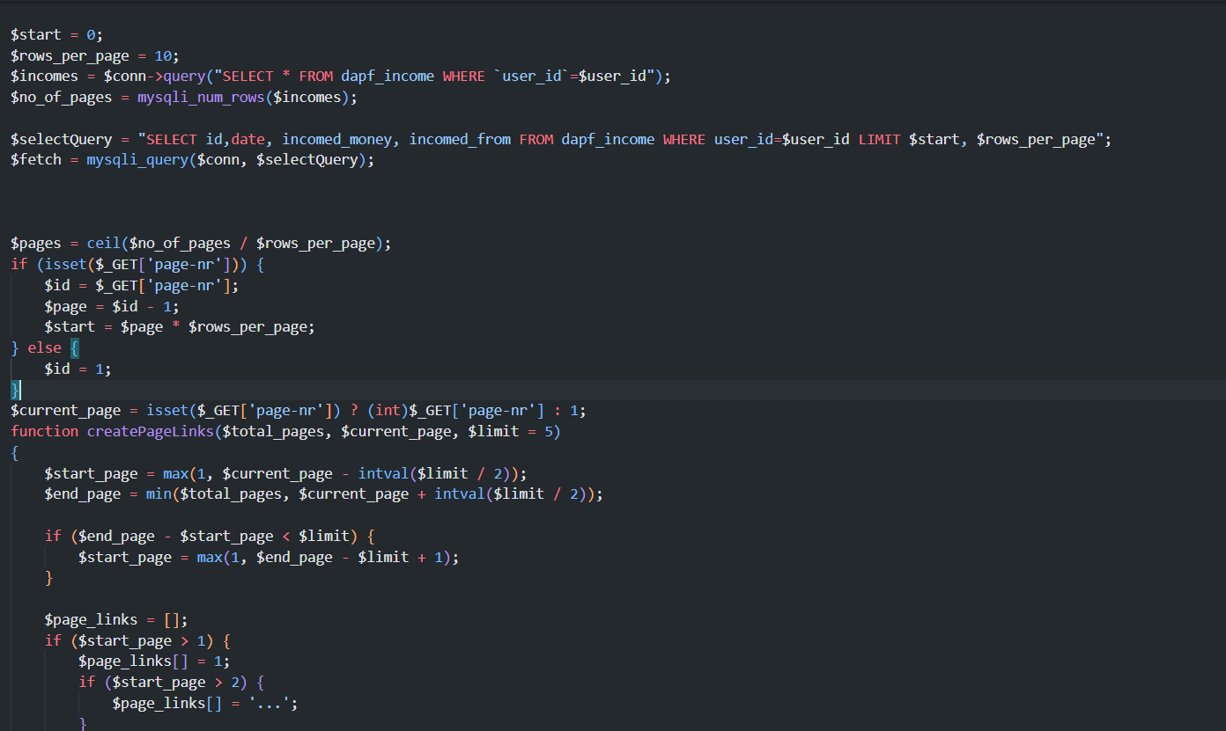

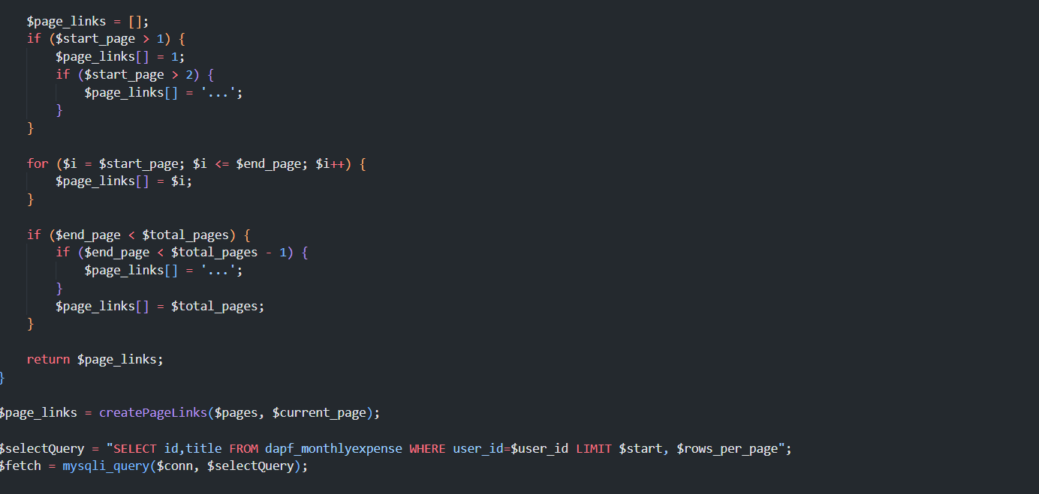

**Figure 4.1 Pagination Module**

**4.1.2.2 Budget Allocation**

Users can allocate budgets for their expenses with the help of the Budget Allocation functionality. This feature helps them manage their expenses systematically. Budget allocation is crucial for maintaining financial discipline and ensuring that users do not overspend in any category.

In our Daily Activities and Personal Finance Tracker system, the Budget Allocation functionality allows users to set specific budget limits for different expense categories, such as groceries, entertainment, and utilities. The system then tracks their spending against these budgets, providing real-time updates and alerts if they approach or exceed their limits. This helps users stay on top of their finances, make informed spending decisions, and achieve their financial goals more effectively.

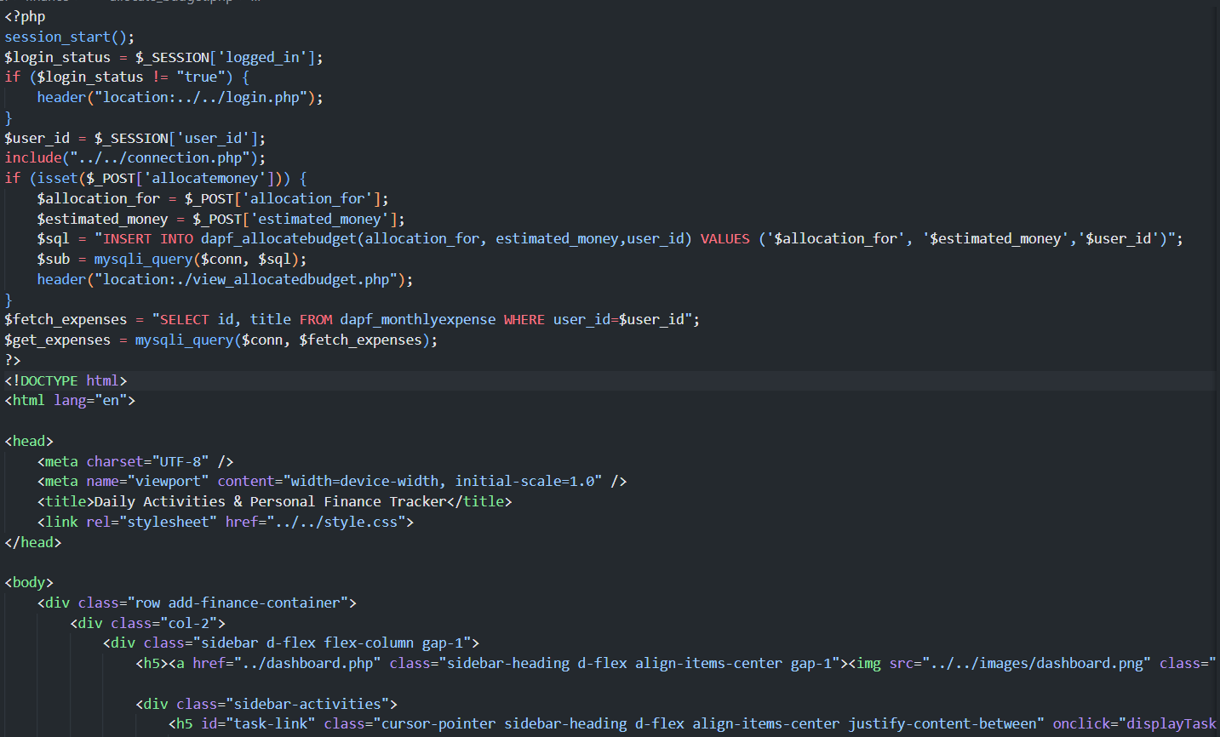

**Figure 4.2 : Budget Allocation Module**

## **4.2 Testing**

Testing is one of the processes in the Software Development Life Cycle (SDLC). It is done to ensure that a system functions as intended. Our system has been tested using different testing methods. These methods are:

### **4.2.1 Test Case for Unit Testing**

Unit Testing is the testing of individual modules. The different Unit Testing tested in our project are:

**User Registration**

**Table 1Test Case for User Registration**

|  |  |  |  |  |  |
| --- | --- | --- | --- | --- | --- |
| S.N. | Test Name | Inputs | Expected Outcome | Actual Outcome | Result |
| 1 | Open Application | http://localhost/college/project_i/registration.php | DAPF Home Page | DAPF Home Page | Pass |
| 2 | Signup Navigation | Click on signup link | Navigate to Registration Page | Navigate to Registration Page | pass |
| 3 | User Registration | Full Name: John Doe  Email: [john12@gmail.com](mailto:john12@gmail.com)  Password: Johndoe12# | Registration Successful, Redirected to Login Page | Registration Successful, Redirected to Login Page | pass |

The table above represents the unit test cases for user registration. The test cases for user registration include different tests such as Open Application, Signup Navigation, and User Registration.

**User Login**

**Table 2 Test Case For Login**

|  |  |  |  |  |  |
| --- | --- | --- | --- | --- | --- |
| S.N. | Test Case | Inputs | Expected Outcome | Actual Outcome | Result |
| 1 | Login Navigation | Click on Sign in button | Navigate to login page | Navigate to login page | Pass |
| 2 | User Login | Email: [kiran1@gmail.com](mailto:kiran1@gmail.com)  Password: lorem | User Not Found | User Not Found | Pass |
| 3 | User Login | Email: [john12@gmail.com](mailto:john12@gmail.com)  Password: Johndoe12# | Navigate to user dashboard | Navigate to user dashboard | Pass |

Table 4.2 above shows the test cases for user login. Initially, the user navigates to the login page by clicking the sign-in button. When the user attempts to log in with an invalid email and password, an error message "User Not Found" is displayed. When the user tries with the registered email and password, they are redirected to the User Dashboard page.

**Add Task**

**Table 3 Test Case for Adding Tasks**

|  |  |  |  |  |  |
| --- | --- | --- | --- | --- | --- |
| Id | Test Case | Inputs | Expected Outcome | Actual Outcome | Result |
| 1 | Add Task Navigation | Click on the Add Task link in sidebar Lists. | Navigate to Add Task Form. | Navigate to Add Task Form | Pass |
| 2 | Add Task | Title: empty  Importance: empty  Due Date: Current Date  Summary: empty | Warning: Please Fill out this field | Warning: Please Fill out this field | Pass |
| 3 | Add Task | Title: Studying  Importance: Critical  Due Date: Current Date  Summary: MIS and Ecommerce | Added Successfully! | Added Successfully! | Pass |

Table 4.3 shows the test cases for adding tasks. First, the user navigates to the add task form page by clicking the Add Task button in the sidebar. If the user tries to submit the form with empty fields, a warning message "Please fill out this field" is displayed. When the user submits the form with all fields filled, the task is added successfully.

### **4.2.2 Test Case for System Testing**

**Table 4 Test Case for System Testing**

|  |  |  |  |  |  |
| --- | --- | --- | --- | --- | --- |
| Id | Test Name | Input | Expected outcome | Actual Outcome | Result |
| 1 | User Registration | Full Name: John Doe  Email: [john12@gmail.com](mailto:john12@gmail.com)  Password: Johndoe12# | Registered Successfully and navigated to login page | Registered Successfully and navigated to login page | Pass |
| 2 | Login User | Email: [john12@gmail.com](mailto:john12@gmail.com)  Password: Johndoe12# | Redirected to User Dashboard. | Redirected to User Dashboard. | Pass |
| 3 | Add Tasks | Title: Studying  Importance: Critical  Due Date: Current Date  Summary: MIS and Ecommerce | Added Successfully! | Added Successfully! | Pass |
| 4 | Add Income | Incomed Money: 5000  Income Source: Pocket Money  Summary: | Added Successfully! | Added Successfully! | Pass |
| 5 | Add Expense | Money Spent: 3000  Money Spent On: Travelling.  Summary : | Added Successfully! | Added Successfully! | Pass |

# **CHAPTER 5: CONCLUSION AND FUTURE RECOMMENDATION**

## **5.1 Lesson Learnt/outcomes**

Using a daily activities and personal finance tracker system teaches the importance of discipline and routine, as it requires consistent logging of daily tasks and financial transactions. It fosters financial awareness by highlighting spending habits and identifying areas where money can be saved. The system enhances budget management skills by encouraging the allocation of funds to essential categories and preventing overspending. Additionally, it improves time management and productivity by helping to prioritize tasks and set realistic goals. By analyzing the recorded data, users can make informed decisions and better plan for the future. Ultimately, this practice promotes a sense of accountability and responsibility, leading to a more organized and financially secure lifestyle.

## **5.2 Conclusion**

In conclusion, the implementation of a daily activities and personal finance tracker system provides significant benefits that contribute to both personal and financial well-being. This system promotes a disciplined approach to managing daily tasks and finances, fostering greater financial awareness and improved budgeting skills. By consistently tracking income, expenses, and activities, users gain valuable insights into their spending habits and time management, leading to more informed decision-making and goal setting. The ability to analyze data trends supports long-term planning and enhances overall productivity. Ultimately, the tracker system encourages accountability, reduces financial stress, and helps users achieve a more organized, efficient, and financially secure lifestyle.

## **5.3 Future Recommendations**

The several future recommendations that could be added in the future are:

* **Chart System**

In the future, we plan to display the concluded data through charts over various time frames. These charts will play a crucial role in visualizing the information, making it easier to identify patterns and trends at a glance. By presenting the data graphically, users can quickly grasp complex information, compare different time periods, and make more strategic decisions

* **Excel and PDF**

We will also allow users to download the data in Excel and PDF formats. Providing data in Excel format is essential for users who wish to perform further analysis, create custom reports, or manipulate the data according to their specific needs. Excel's robust functionality enables users to apply advanced formulas, pivot tables, and other analytical tools. On the other hand, offering data in PDF format ensures that users have access to a standardized, easily shareable, and printable version of their data.

* **Search Functionality**

we are going to enable users to search data within the table. The search functionality is vital for users to quickly locate specific information without sifting through large amounts of data manually. This feature enhances the user experience by saving time and effort, allowing for faster retrieval of relevant data.

# **REFERENCES**

[1] Google Inc., "Track your goals and daily tasks with Google Keep," Google Keep. [Online]. Available: <https://keep.google.com>. [Accessed: 13-Jul-2024].

[2] Bordio Inc., "Manage tasks and projects with Bordio," Bordio. [Online]. Available: <https://app.bordio.com/>. [Accessed: 13-Jul-2024].

[3] TimeNotes, "Track your time and manage your projects," TimeNotes. [Online]. Available: <https://app.timenotes.io>. [Accessed: 13-Jul-2024].

[4] Clockify, "Free Time Tracking Software," Clockify. [Online]. Available: <https://app.clockify.me>. [Accessed: 13-Jul-2024].

[5] EveryDollar, "Budgeting App and Software," EveryDollar. [Online]. Available: <https://www.everydollar.com>. [Accessed: 13-Jul-2024].

# **APPENDICES**

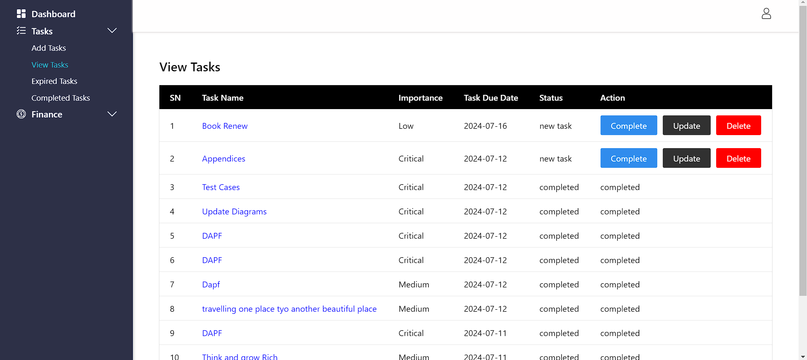

**Fig: Tasks Lists**

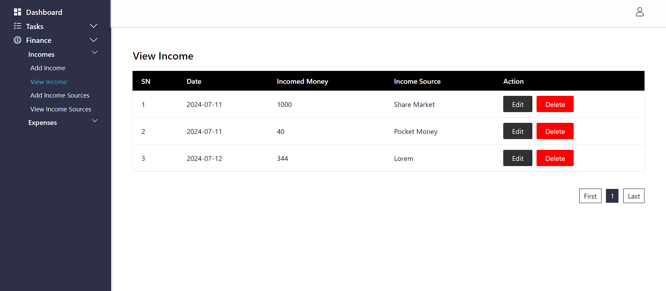

**Fig: Incomes Lists**

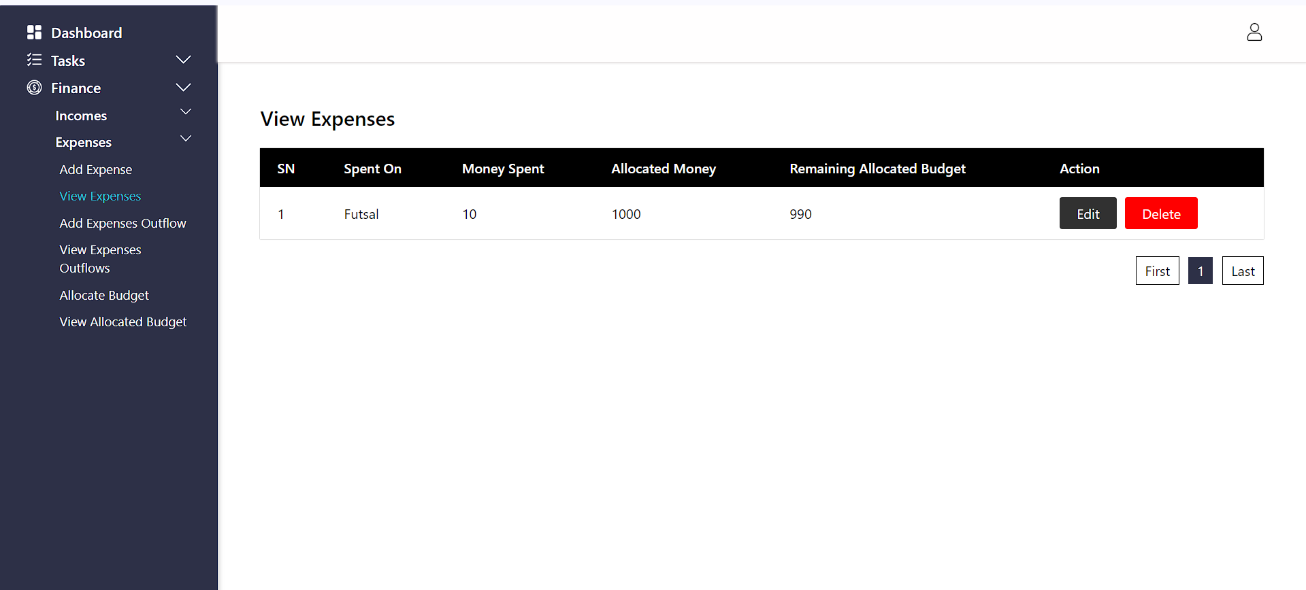

**Fig: Expenses Lists**